Exp No:28
COUNTING SEMAPHORE IN SYSTEMC
AIM:
To implement Counting Semaphore allowing multiple resource access.
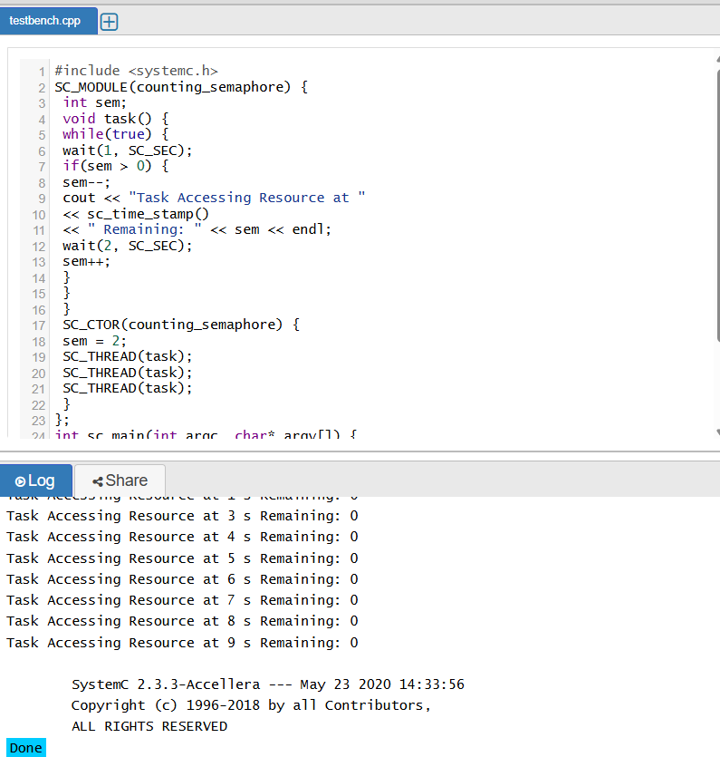
RESULT:
Thus the Counting Semaphore was created using SystemC and verified

